Step1 - Application starts by displaying the login page for the administrator to login in

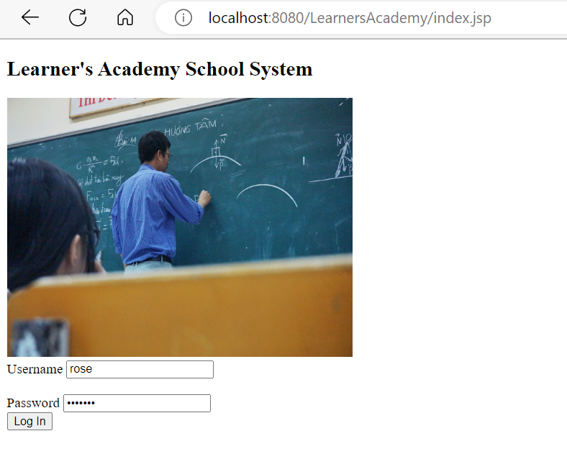

Step 2: Take user input and check if credentials are correct. Stay on login page and show error message if credentials are not correct.

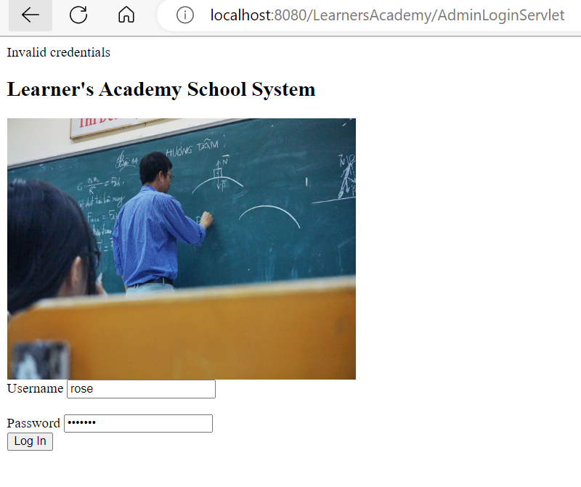

Step3. Display dashboard page with menu items if credentials are correct

|  |
| --- |
|  |

Step 4 – Select an item from the menu options

1. Set up a master list of all the subjects for all the classes. Admin can add a new subject to the master list.

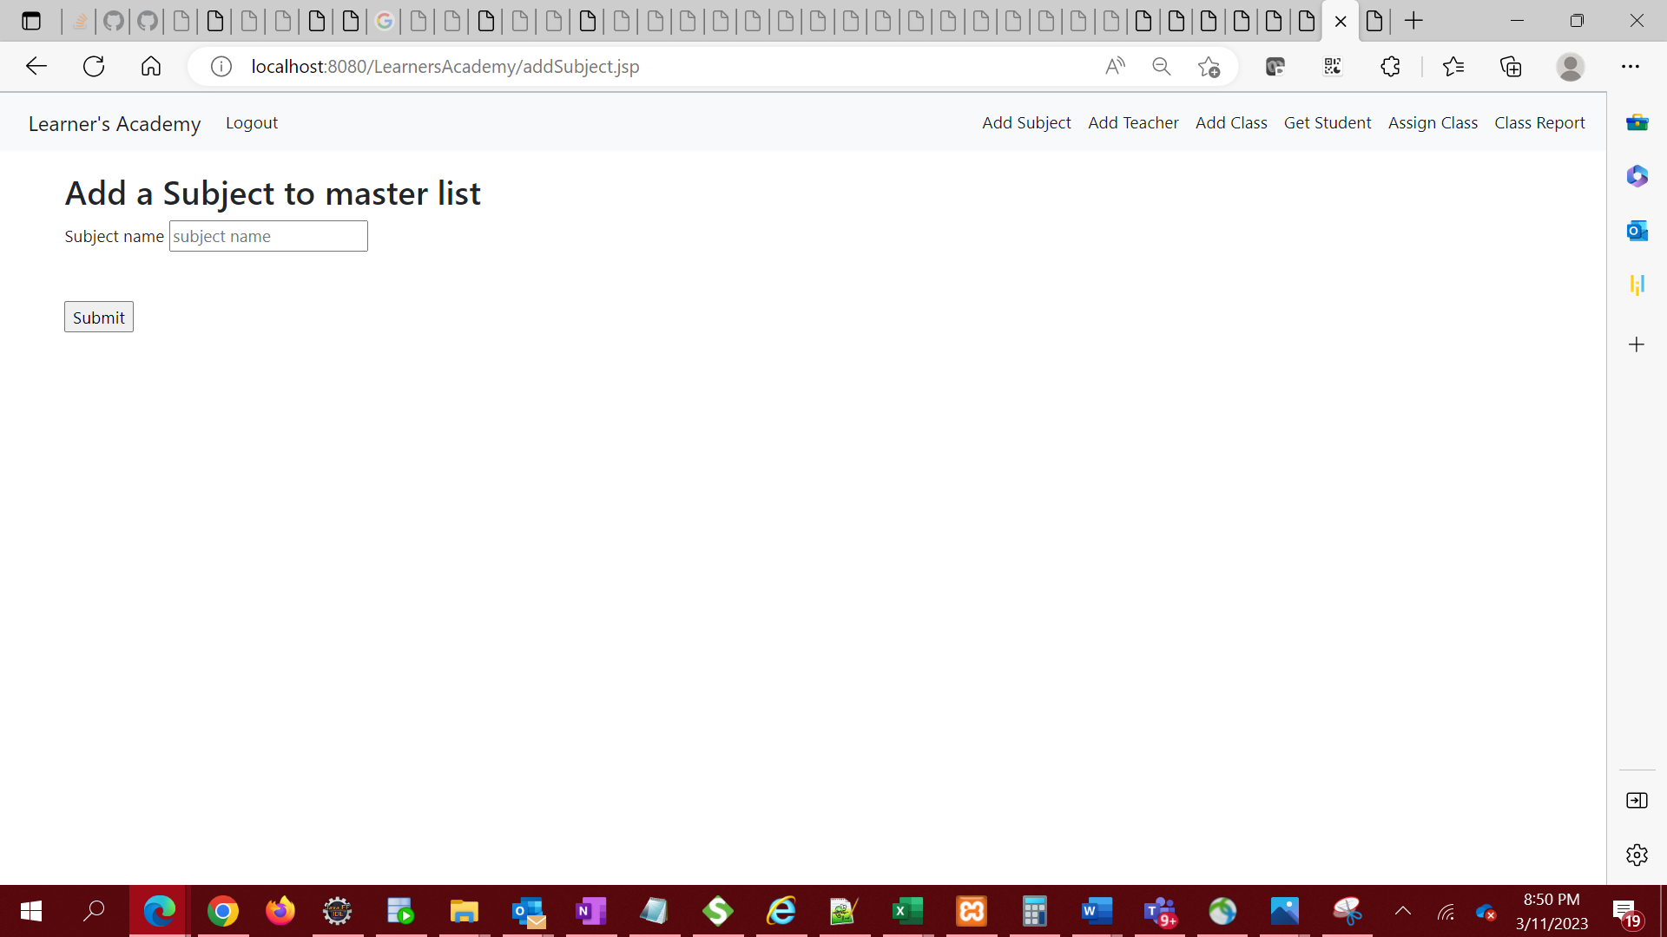

i. Validate input to ensure field is not empty on submission. If input is empty, stay on same page and display error message in url.

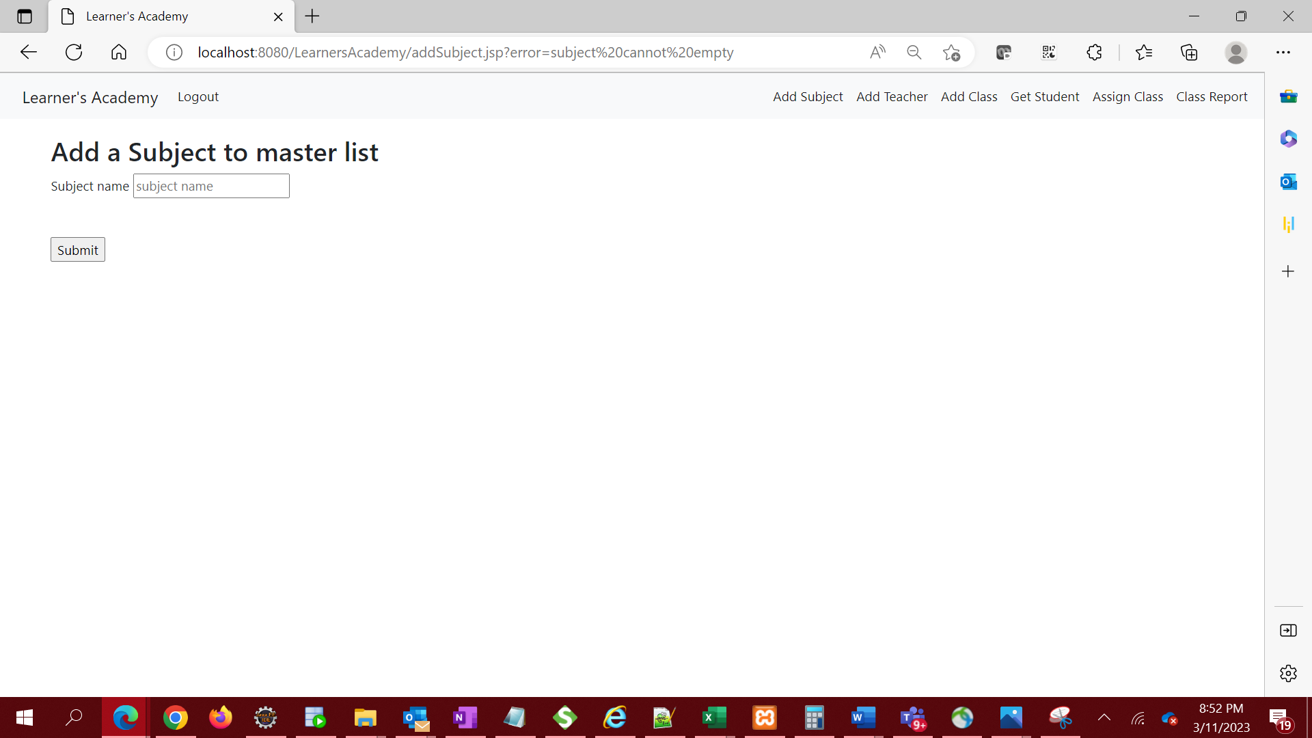

ii. If input is not empty, submit to database and redirect to subjects page to view the subject added

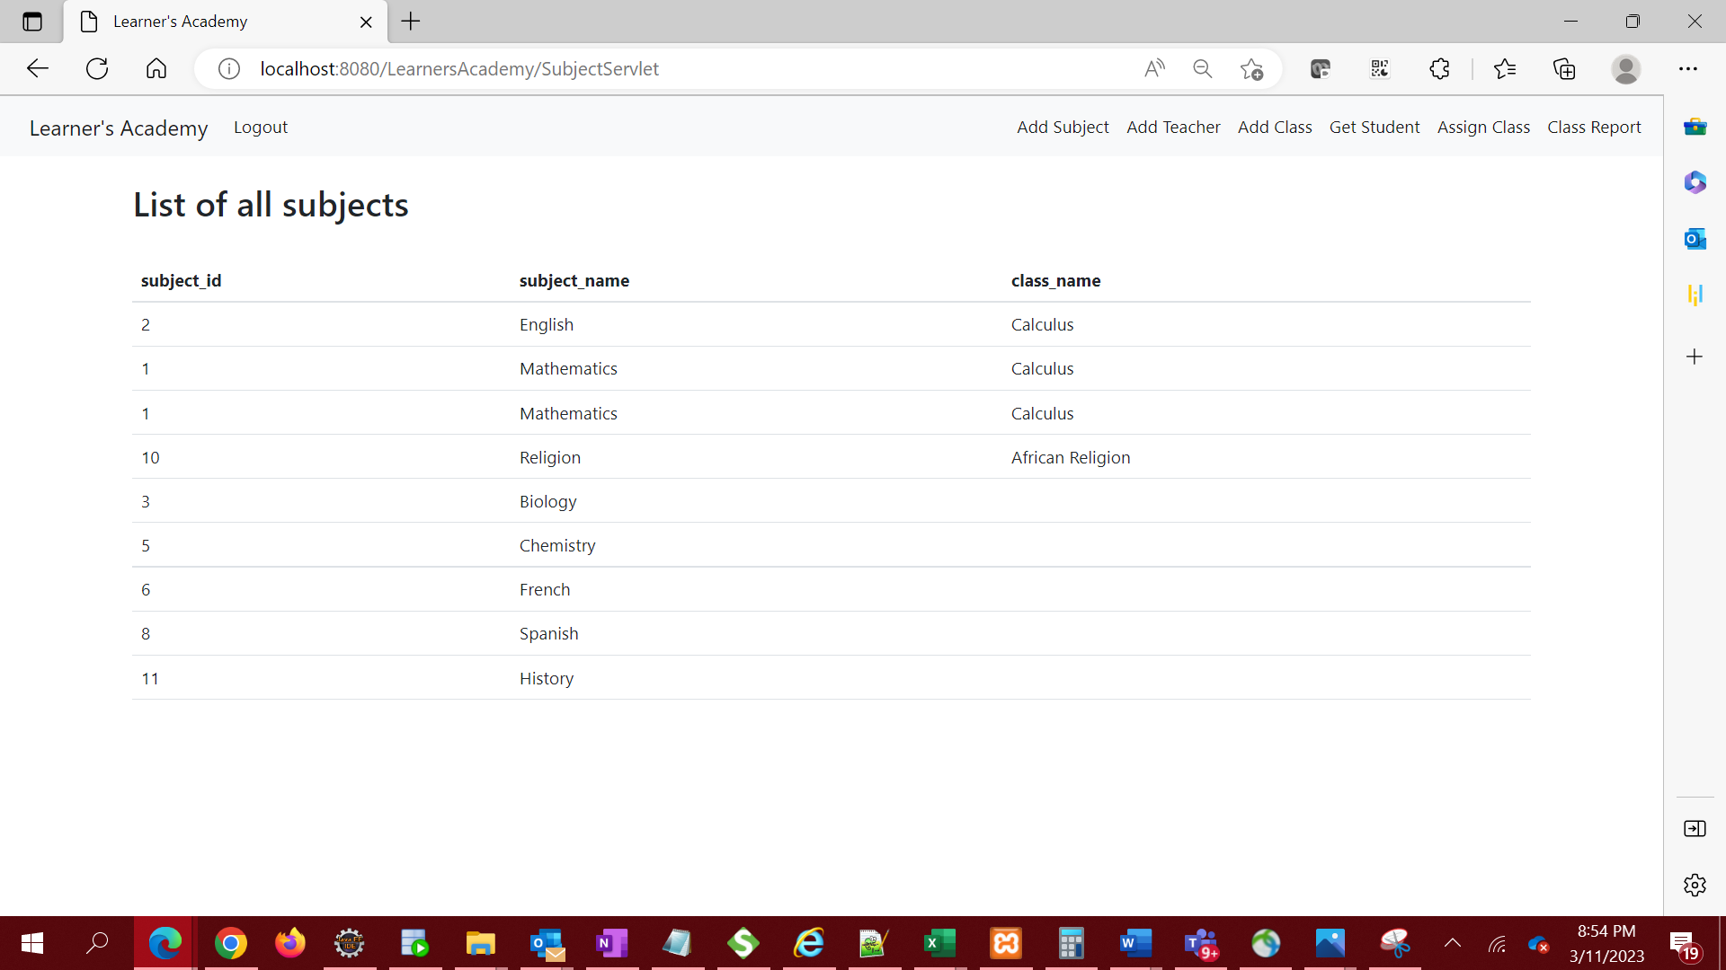

1. Set up a master list of all the teachers

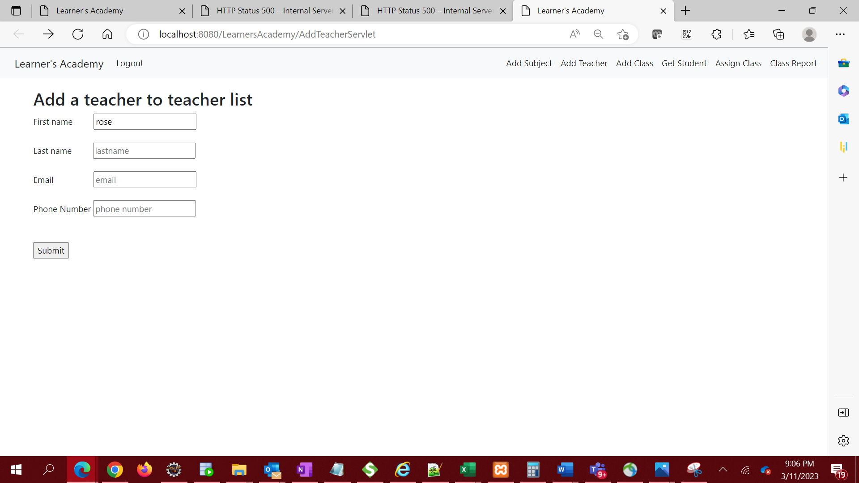

i. Validate input to ensure field is not empty on submission. If input is empty, stay on same page and display error message in url.

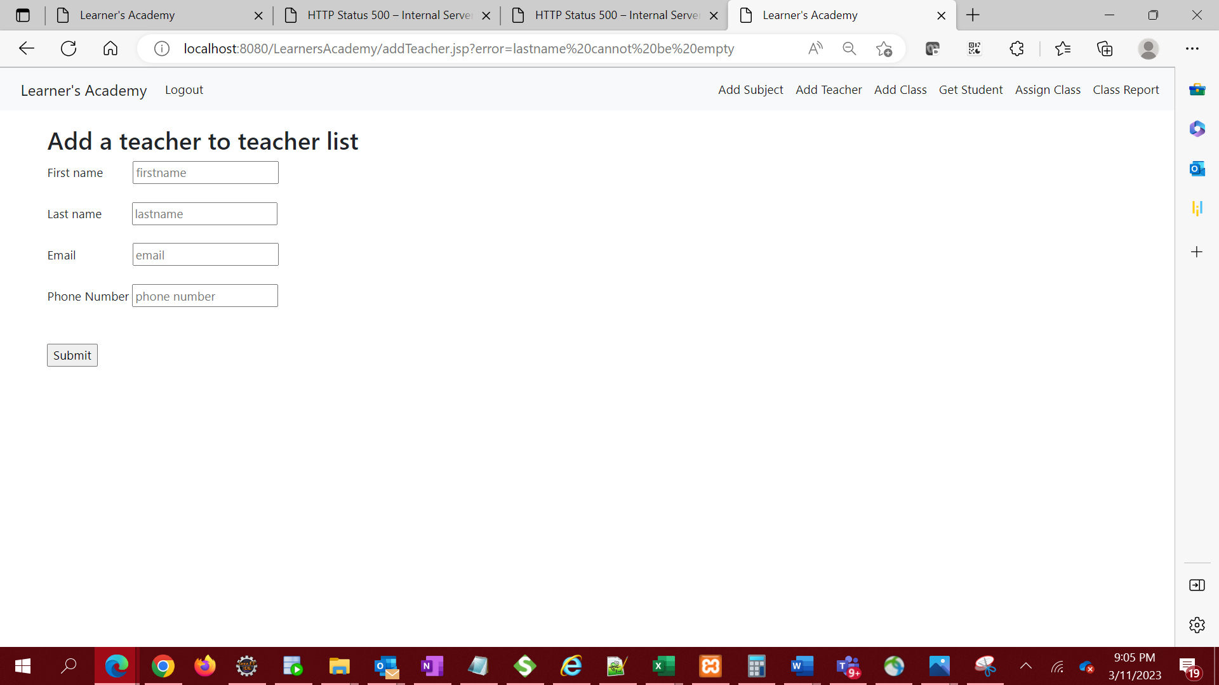

ii. If input is not empty, submit to database and redirect to View teacher’s page to view the teacher added.

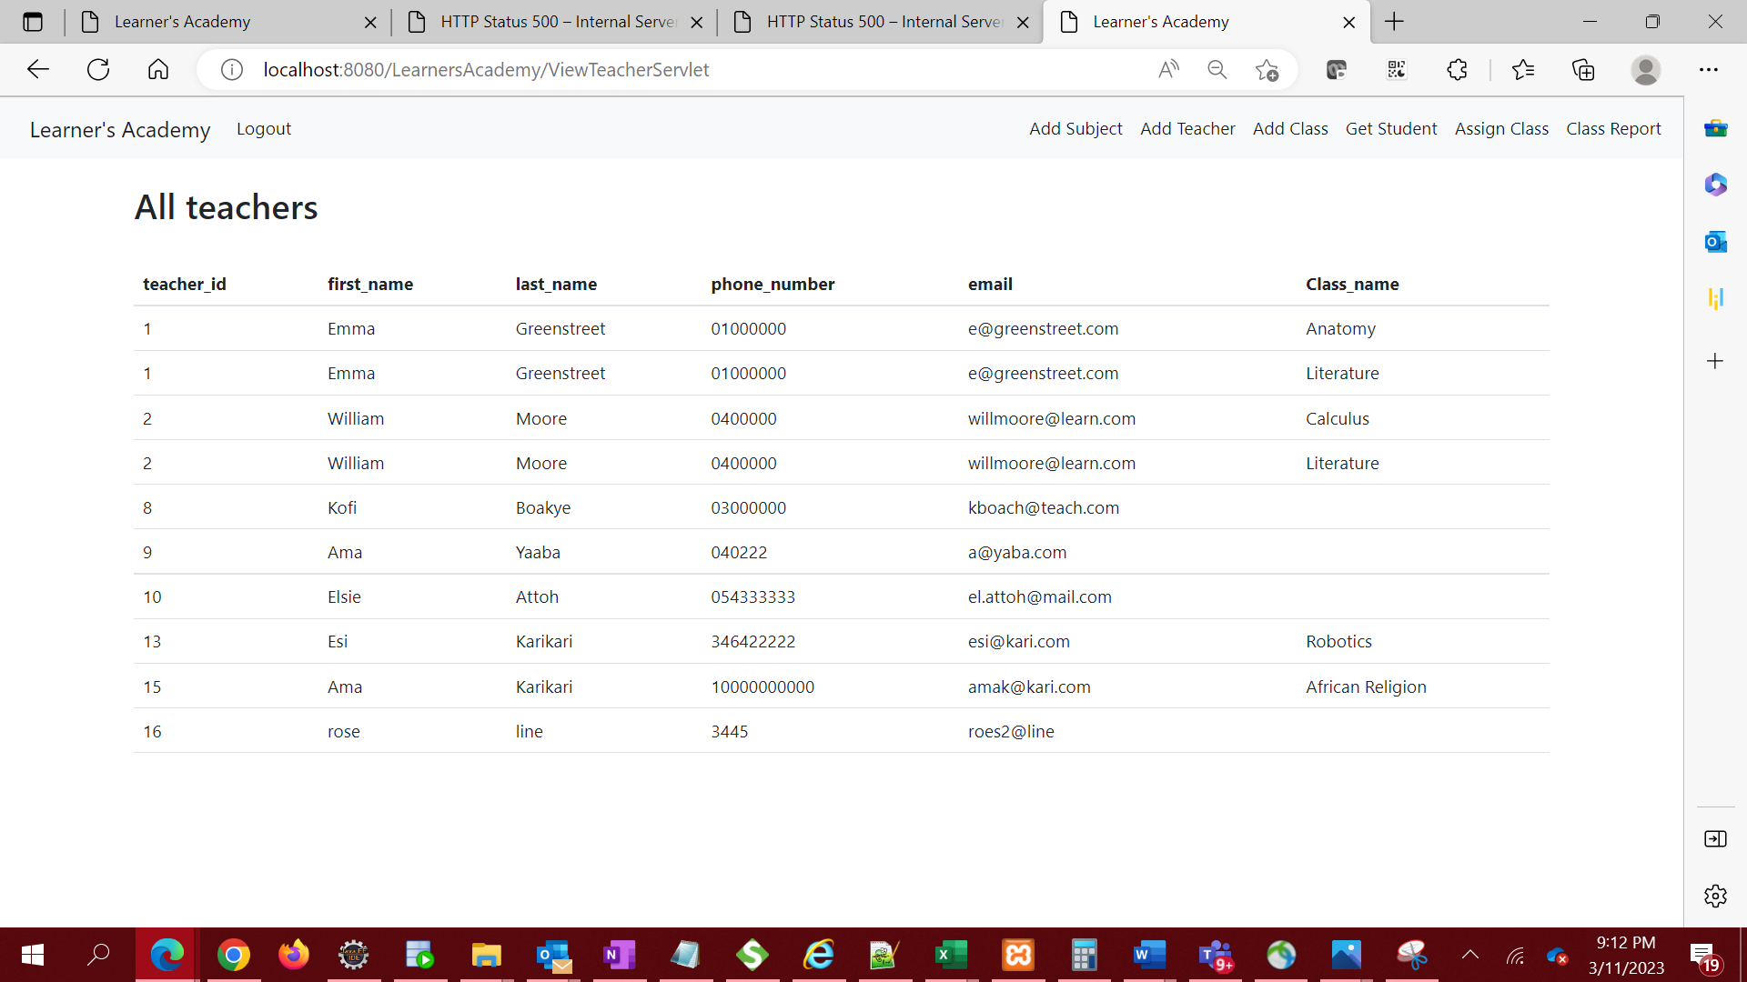

1. Set up a master list of all the classes

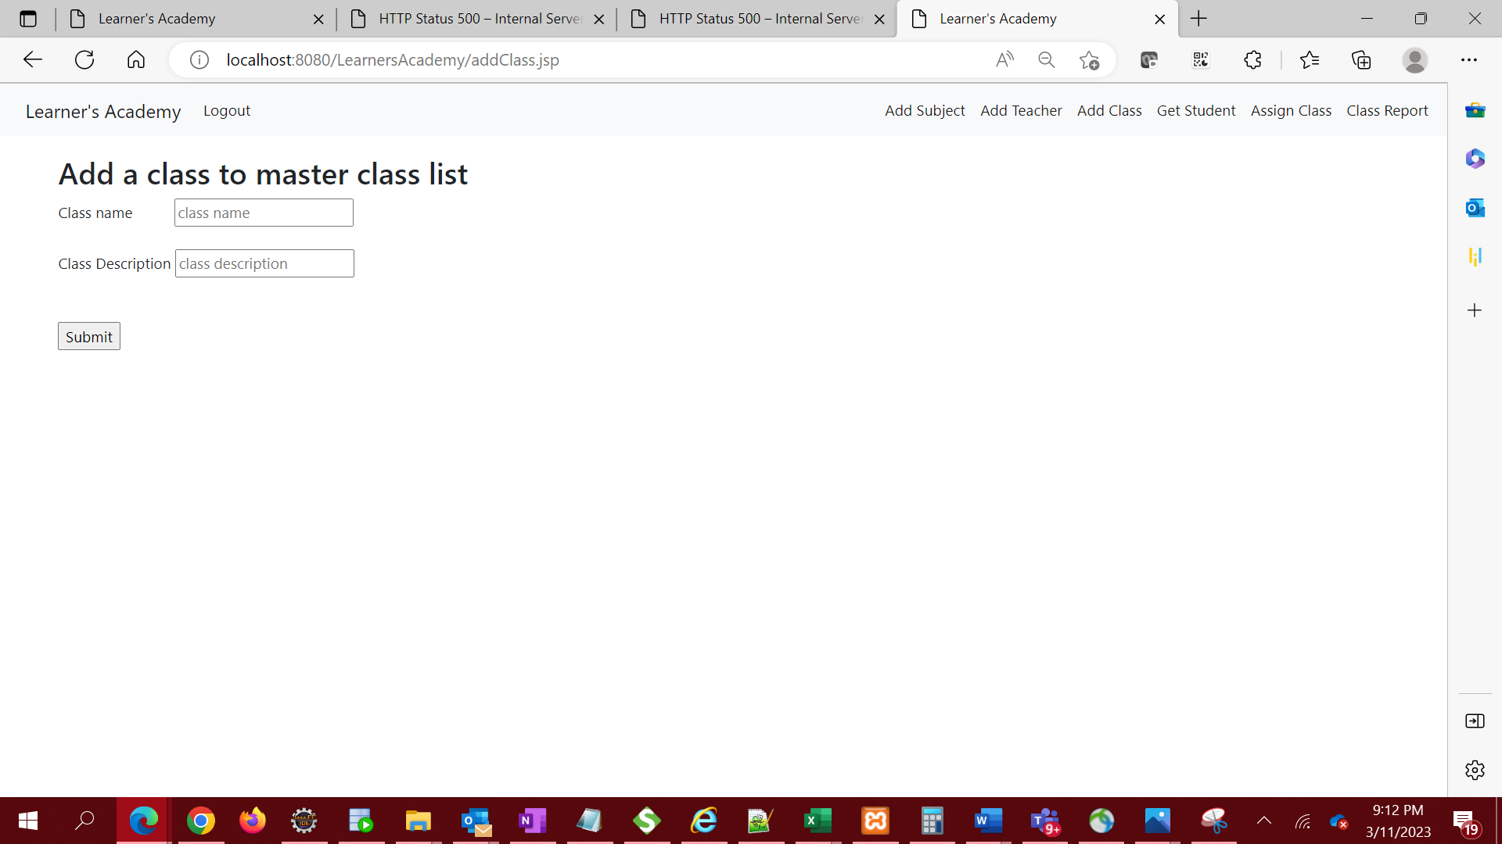

1. Validate input to ensure field is not empty on submission. If input is empty, stay on same page and display error message in url.

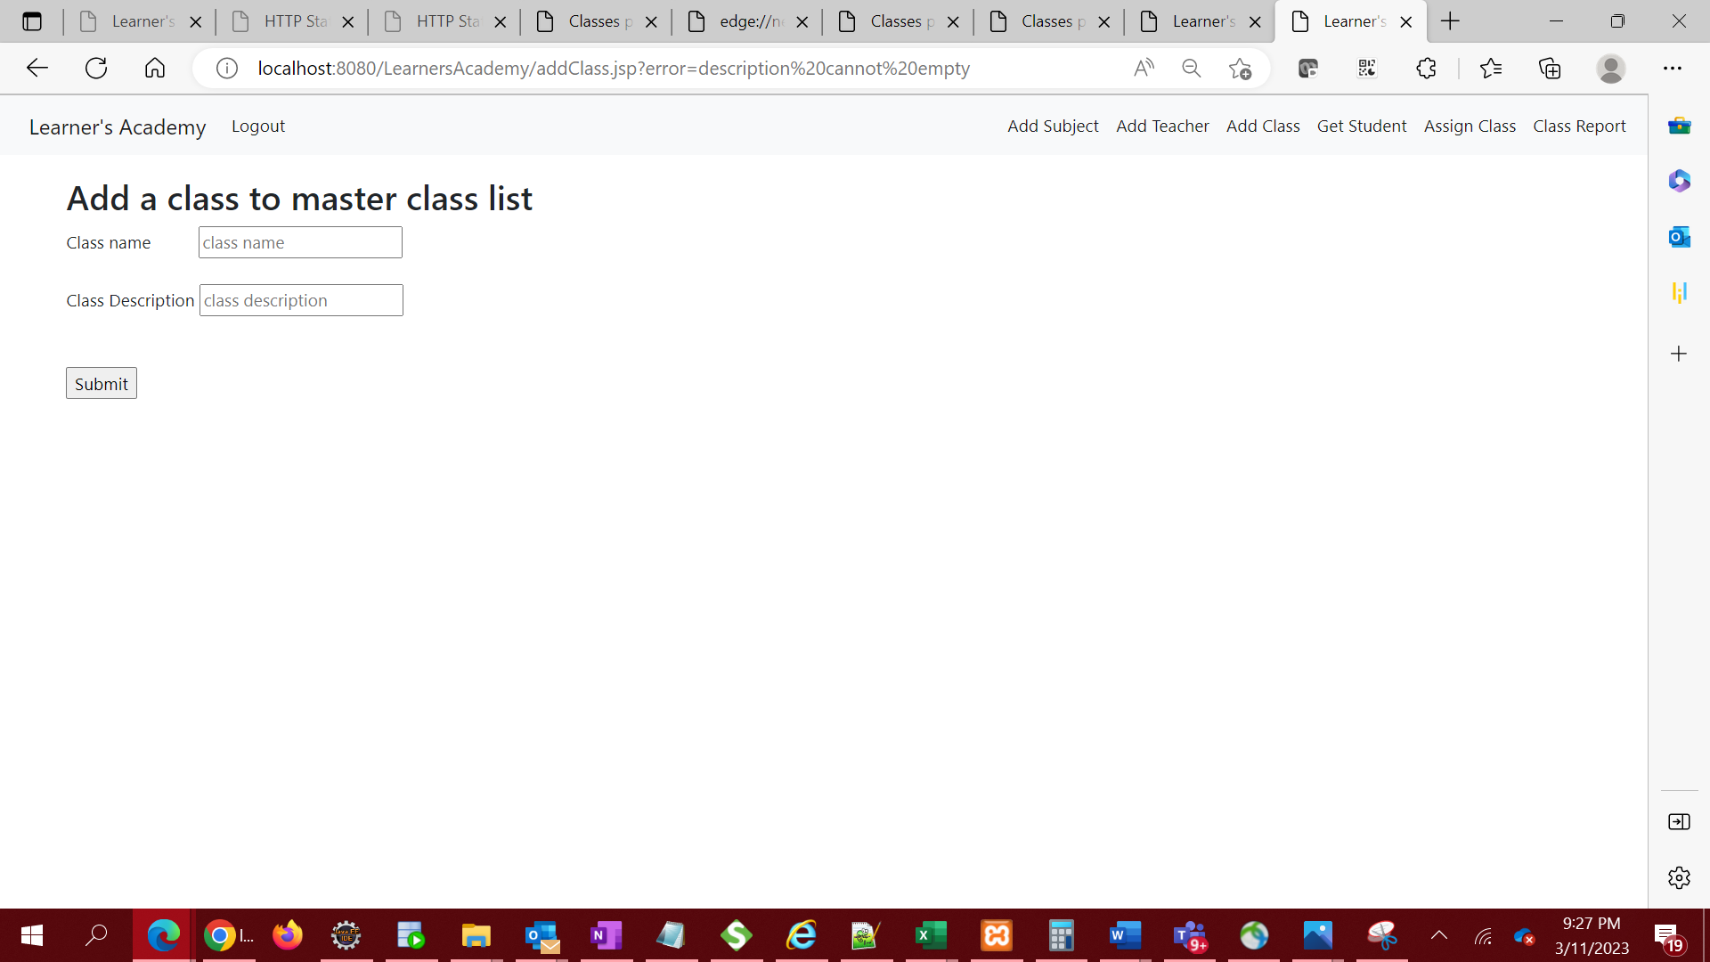

1. If input is not empty, submit to database and redirect to View Class page to view the class added.

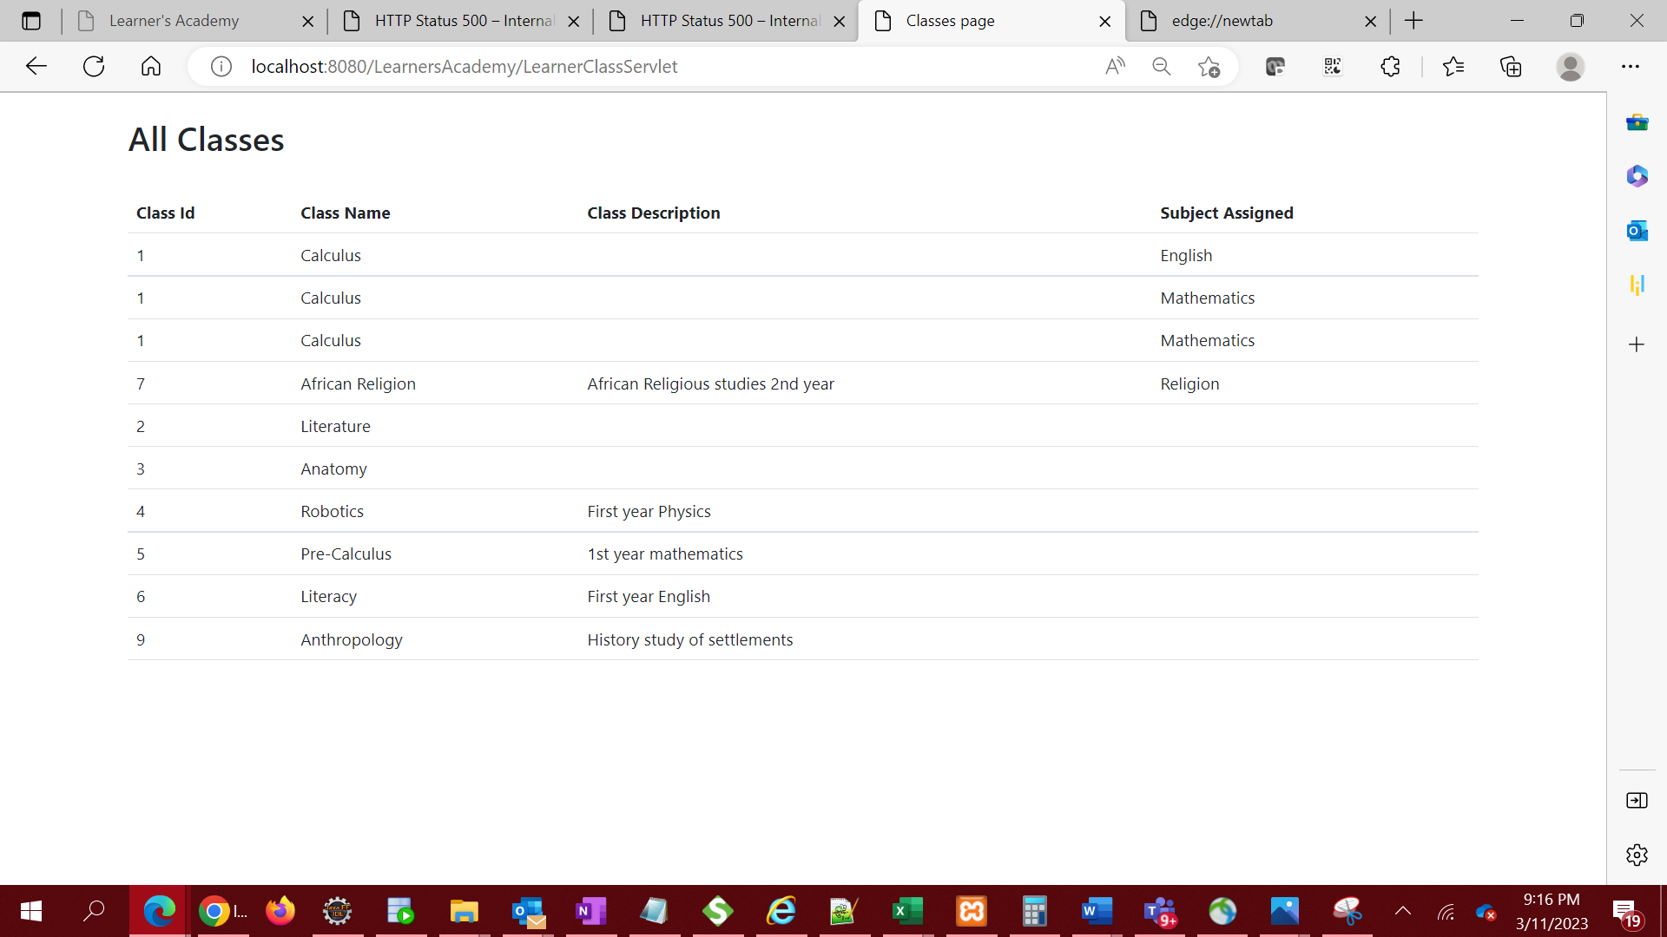

1. Assign classes for subjects from the master list

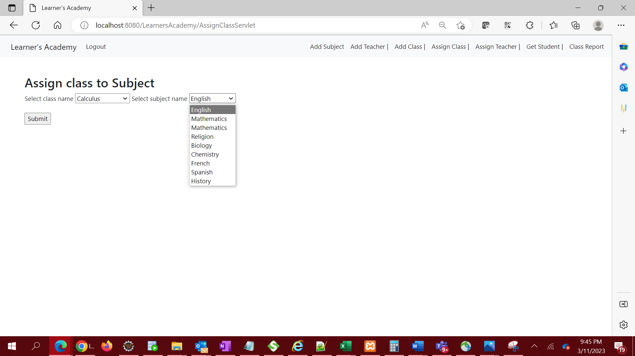

1. submit to database and redirect to All Class page to view the class subject assigned.

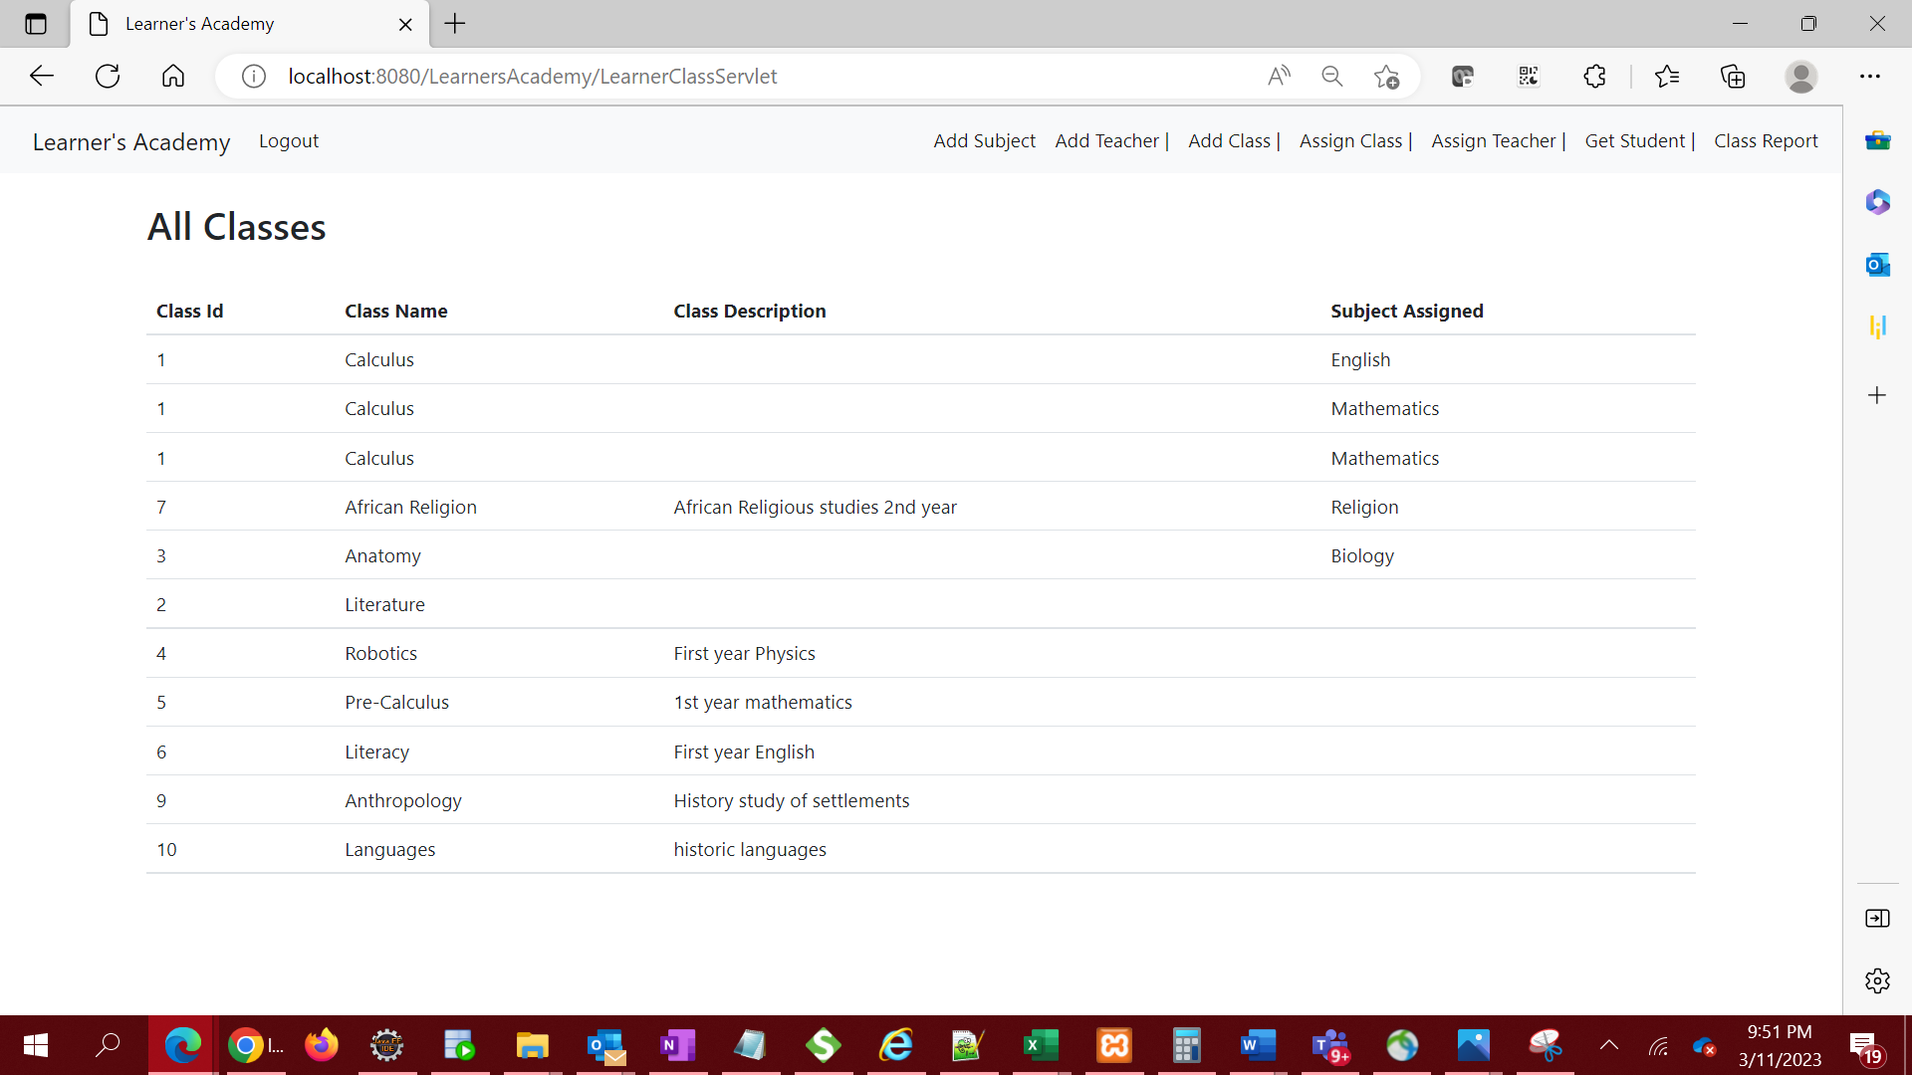

1. Assign teachers to a class for a subject

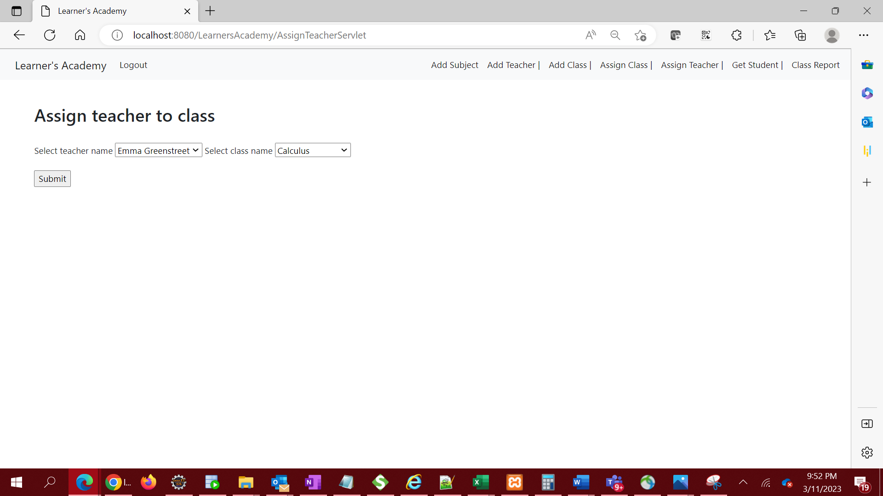

1. submit to database and redirect to All teachers page to view the teacher and class assigned.

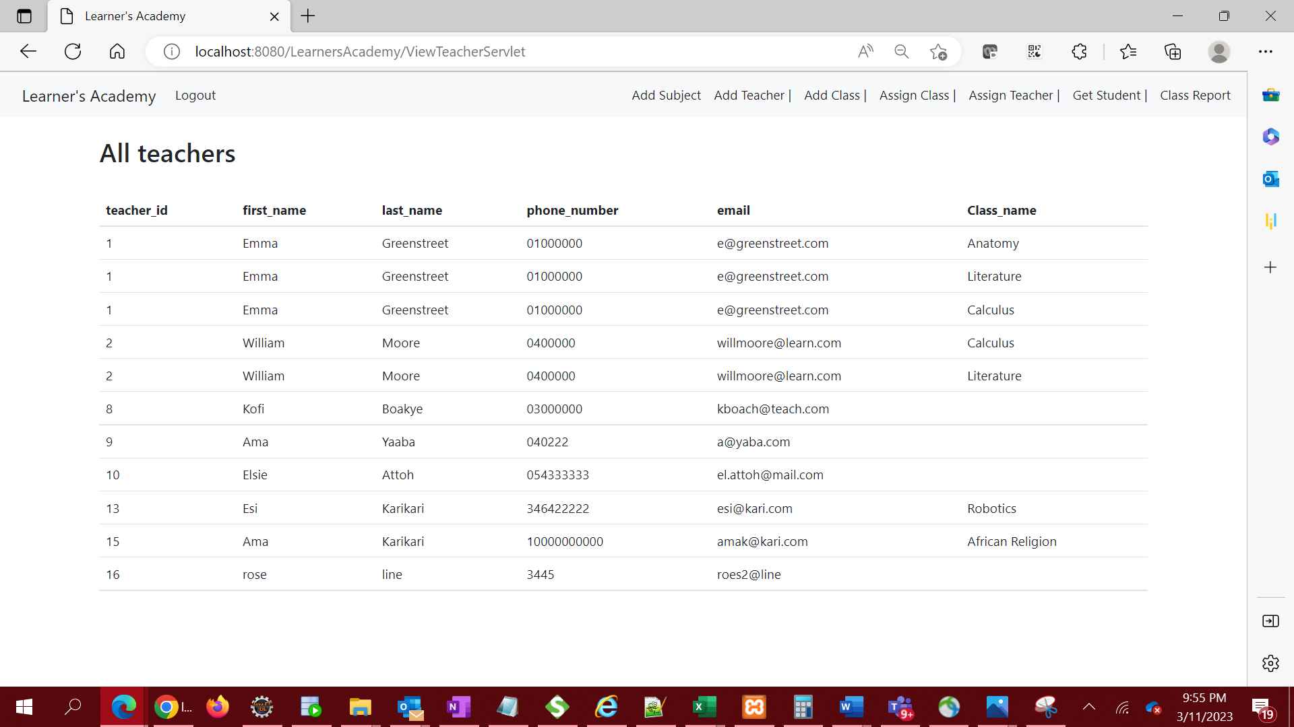

1. Get a master list of students – Fetch student list from database and display on All Students page

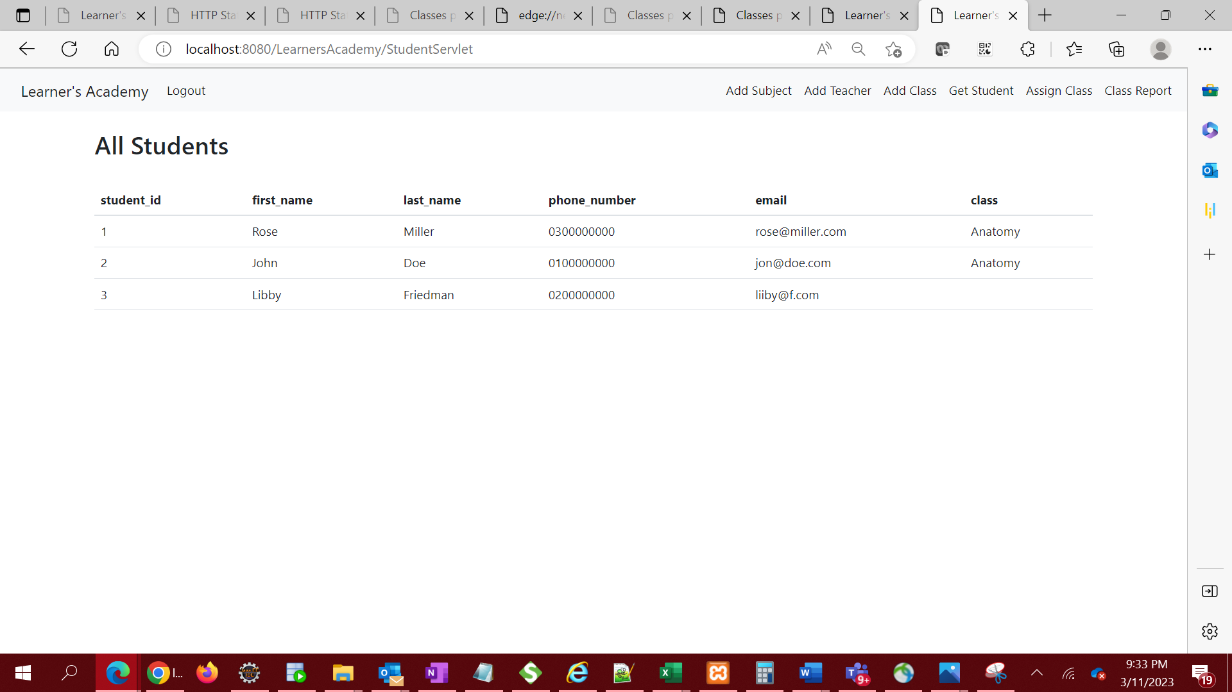

1. View Class Report show all the information about all the class, such as the list of students, subjects, and teachers

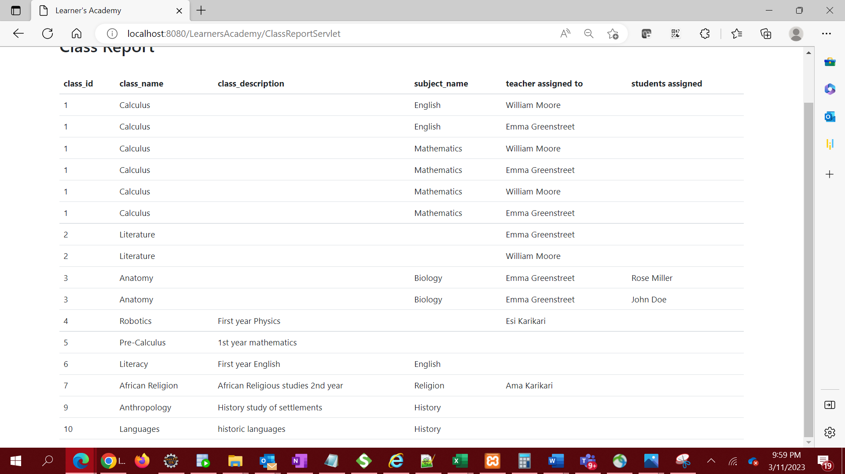

1. Logout of the application.

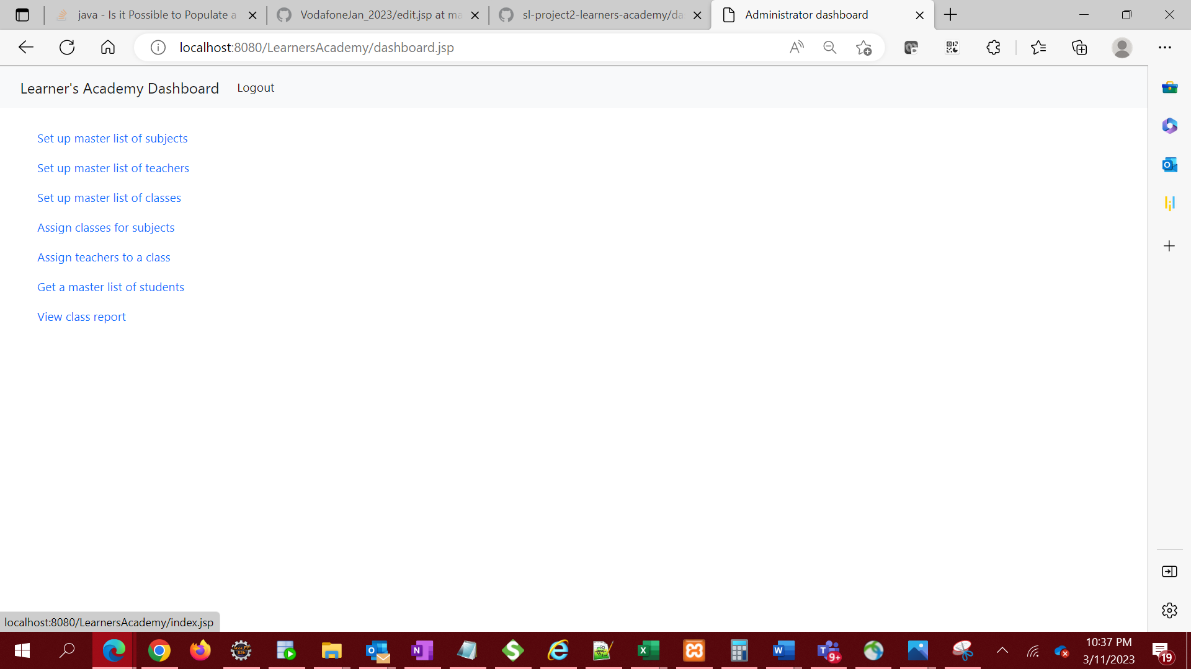

1. Logout of the application takes administrator back to the login page.

